Minimum Segment Area in RayStation

The default minimum segment area in IMRT/IMRT plans is specified in Clinic Settings for both SMLC (IMRT) and VMAT techniques:

**SMLC: VMAT:**

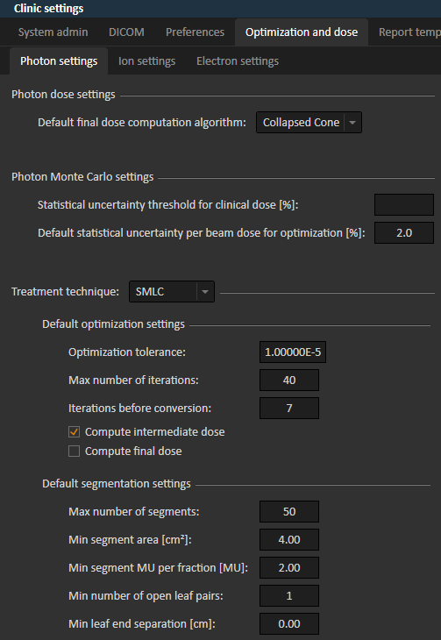 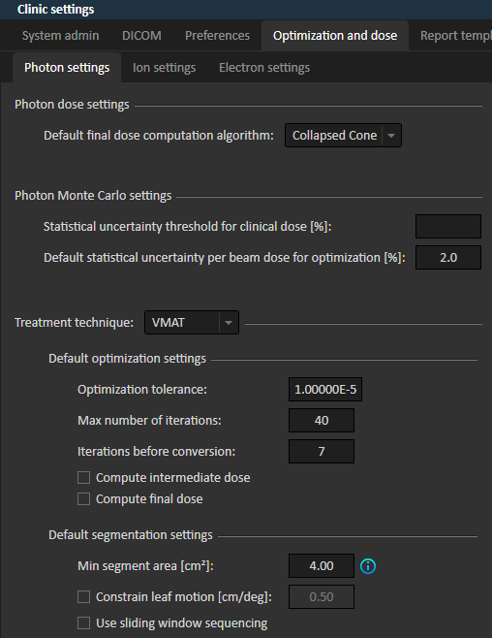

In an SMLC plan, this default populates an optimization setting, but VMAT is restricted to the default.

**SMLC: VMAT:**

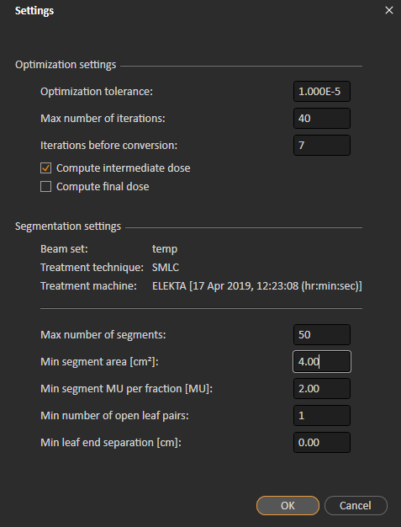 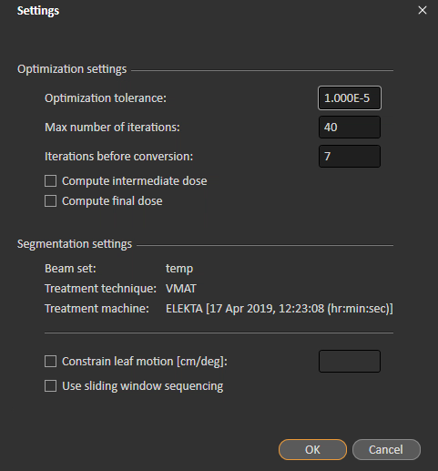

In RayPhysics, you can find the minimum value that you can enter into either Clinic Settings or a plan’s Optimization Settings. Ensure that **Allow interdigitation** is checked.

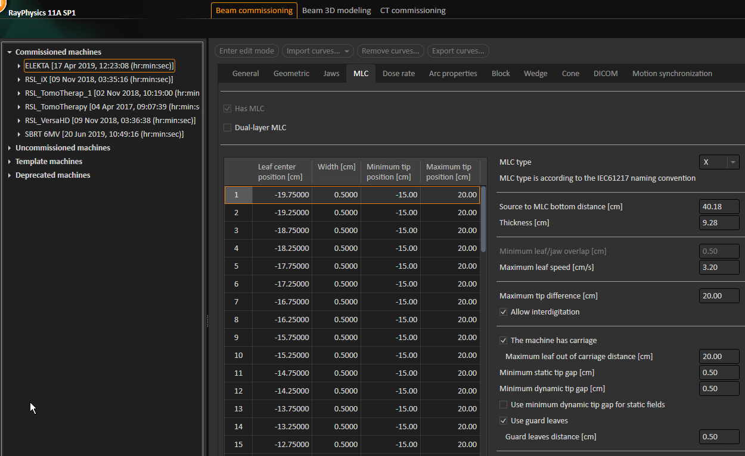

**SMLC**

**VMAT**